**FLOOD MONITORING SYSTEM**

**TEAM MEMBERS**

622621121018: HARIGOPINATH.V

PHASE 1 Submission Document

Project: Flood monitoring syste

Introduction: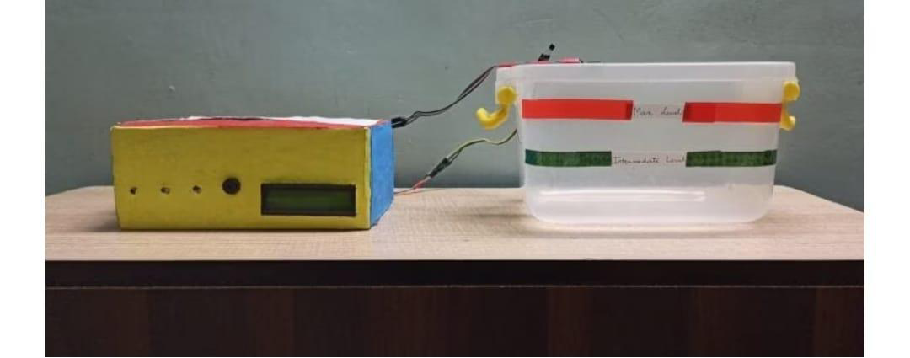As we all know that Flood is one of the major well known Natural Disasters. When water level suddenly rises in dams, river beds etc. Alot of Destruction happens at surrounding places. It causes a huge amount of loss to our environment and living beings as well. So in these case, it is very important to get emergency alerts of the water level situation in different conditions in the river bed.  
  
The purpose of this project is to sense the water level in river beds and check if they are in normal condition. If they reach beyond the limit, then it alerts people through LED signals and buzzer sound. Also it alerts people through Sms and Emails alerts when the water level reaches beyond the limit.  
  
Excited? Let's get started.

### **Things used in this project**

#### **Hardware components -**

1. Bolt-IoT wifi module
2. Arduino uno
3. Breadboard- 400 tie points
4. 5mm LED:(Green, Red, Orange) and Buzzer
5. 16×2 LCD Display
6. LM35 Temperature Sensor
7. HC-SR04 Ultrasonic Sensor
8. Some Jumper Wires
   1. Male to Female Jumper Wires- 15 pcs
   2. Male to Male Jumper Wires- 10 pcs
   3. Female to Female Jumper Wires- 5 pcs
9. 9v Battery and Snap Connector
10. USB Cable Type B

#### **Software components -**

1. [Arduino IDE](https://www.arduino.cc/en/software)
2. [Python 3.7 IDLE](https://www.python.org/downloads/)
3. [Bolt IoT Cloud](https://cloud.boltiot.com/)
4. [Bolt IoT Android App](https://play.google.com/store/apps/details?id=com.bolt.com.bolt)
5. [Twillo SMS Messaging API](https://www.twilio.com/)
6. [Mailgun EMAIL Messaging APISoftware components](https://www.mailgun.com/)

#### **Hand tools and fabrication machines**

1. Electrical Tape
2. Green Cello Tape

## **Hardware Setup**

For Building this project we first configure the hardware connections. Then later on moving to the software part.

**Step 1**: **Connecting 5v and GND of Arduino to the Breadboard for power connection to other components.**

**Connecting 5v and GND of Arduino**

**Step 2**: **Connecting LED’s**

**For Green LED:**

* VCC of Green Colour LED to Digital Pin ‘10’ of the Arduino.
* GND of Green Colour LED to the GND of Arduino.

**For Orange LED:**

* VCC of Orange Colour LED to Digital Pin ‘11’ of the Arduino.
* GND of Orange Colour LED to the GND of Arduino.

**For Red LED:**

* VCC of Red Colour LED to Digital Pin ‘12’ of the Arduino.
* GND of Red Colour LED to the GND of Arduino.

For Red LED

**Step 3**: **Connecting Buzzer**

* VCC of Buzzer to Digital Pin ‘13’ of the Arduino.
* GND of Buzzer to the GND of Arduino.

Connecting Buzzer

**Step 4**: **Connecting HC-SR04 Ultrasonic Sensor**

* VCC of Ultrasonic Sensor to 5v of Arduino.
* GND of Ultrasonic Sensor to GND of Arduino.
* Echo of Ultrasonic Sensor to Digital Pin ‘8’ of Arduino.
* Trig of Ultrasonic Sensor to Digital Pin ‘9’ of Arduino.

Connecting HC-SR04 Ultrasonic Sensor

**Step 5: Connecting Bolt WiFi Module**

* 5v of Bolt WiFi Module to 5v of Arduino.
* GND of Bolt WiFi Module to GND of Arduino.
* TX of Bolt WiFi Module to RX of Arduino.
* RX of Bolt WiFi Module to TX of Arduino.

**Step 6: Connecting LM35 Temperature Sensor**

* VCC of LM35 to 5v of Bolt WiFi Module.
* Output Pin of LM35 to Pin ‘A0’ of Bolt WiFi Module.
* GND of LM35 to GND of Bolt WiFi Module.

Connecting LM35 Temperature Sensor

**Step 7:Connecting 16×2 LCD Display**

* Pin 1,3,5,16 of 16×2 LCD to GND of Arduino.
* Pin 2,15 of 16×2 LCD to 5v of Arduino.
* Pin 4 of 16×2 LCD to Digital Pin ‘2’ of Arduino.
* Pin 6 of 16×2 LCD to Digital Pin ‘3’ of Arduino.
* Pin 11 of 16×2 LCD to Digital Pin ‘4’ of Arduino.
* Pin 12 of 16×2 LCD to Digital Pin ‘5’ of Arduino.
* Pin 13 of 16×2 LCD to Digital Pin ‘6’ of Arduino.
* Pin 14 of 16×2 LCD to Digital Pin ‘7’ of Arduino.

Connecting LM35 Temperature Sensor

After doing the hardware connection put all the hardware components in one box.

Connecting 16×2 LCD  Display- 3

Also attach LM35 Temperature Sensor on the side of the container.

Side-View

Also attach Ultrasonic sensor on the top of the container.

Ultrasonic sensor on the top of the container.

## **Software Programming**

After the successful completion of hardware setup. Now it’s the time to do software setup for the project. For that you have to first Download and Install Arduino IDE and Python IDE from the link given above in the software apps and online services section. Also Creating account on various online app services and noting down the important keys and id’s. Below all the steps given to create account on online app services and noting down the keys.

**Step 1**:**Creating an account on Twillo and setting up Twillo for sending Sms alerts.**

* Visit <https://www.twilio.com/>.
* Create account by clicking sign up, fill required details.
* Confirm your email.
* You will need to authenticate your phone number on which the sms alerts will be notified.
* Enter the code sent to your phone
* When prompted ” Do you write code?” Click yes
* Select python as your programming language
* When prompted “What is your target today? “Choose” Twilio as a project.
* When prompted “What do you want to do first? “Choose” Send or receive a message.
* My First Twilio Project Dashboard page will open. Now you can Edit your Project as “My Project”.
* Get a trial number and save it somewhere and then choose to use this number.
* You will see the ACCOUNT SID and AUTH TOKEN.
* We will need Account Sid, Auth Token and Trial Number of these so save them somewhere.

Creating an account on Twillo

**Step 2**:**Creating an account on Mailgun and setting up Mailgun for sending Email alerts.**

* Visit <https://www.mailgun.com/>.
* Create an account by clicking on the start sending option and by filling up details.
* Verifying your Account.
* Once you have verified your Email after that you have add your phone number.
* After Entering your number. Click on send activation code. After some time you will receive one OTP. Enter the OTP. Click on Enter.
* After Creating account on Mailgun go to the overview option. Click on API and Click on Python.
* After doing this so you will receive API Key and Sandbox URL. Save this both credentials somewhere you will be further using in this project.

Creating an account on Mailgun 

**Step 4:Creating an account on Bolt Cloud and Bolt Android App and Link the Bolt Module to Cloud.**

* Visit [https://cloud.boltiot.com](https://cloud.boltiot.com/).
* Create account using Email-Id and password.(Use the same email which was used to order hardware kit also use same email for app for linking the hardware to cloud.)
* After creating account on cloud. Then Download Bolt Android App from playstore.
* Create a account on the Bolt app with the same email-Id then use the mobile hotspot for linking the Bolt WiFi module to cloud.
* After successful linking of the device to the cloud then go to the cloud website. The Bolt device will show the device as online.
* Go to API section make the API as enable. Copy the API and save somewhere.
* Also copy the Bolt Device Id which is present on Bolt IoT dashboard and save it somewhere.

**Bolt Device Id**

**Bolt Device Id**

**API Key**

**API Key**

**Step 5: Coding**

After setting online app services and saving the keys somewhere. Now most important is to write code and allow sensors attached to microcontroller to take specific decisions.

Basically this project contains two editors to write the code. First is Arduino IDE in that we will write the arduino code. Second the Python IDE in that we will write the configuration file and the main code. Also the download link of both the editor can find above in the online app services section.

**Step 5.1: Writing the code in the Arduino IDE**

* Open the Arduino IDE(Downloaded from the above section).
* Click on new file. Choose the correct file path to save the file. Give appropirate name to the file and add .ino extention to the file and save the file.
* Now the core part of the project is writing code for Arduino Uno. Below this line complete code is given. You can refer the below code.

//IOT Based Flood Monitoring And Alerting System.

#include<LiquidCrystal.h>

LiquidCrystal lcd(2, 3, 4, 5, 6, 7);

const int in = 8;

const int out = 9;

const int green = 10;

const int orange = 11;

const int red = 12;

const int buzz = 13;

void setup() {

Serial.begin(9600);

lcd.begin(16, 2);

pinMode( in , INPUT);

pinMode(out, OUTPUT);

pinMode(green, OUTPUT);

pinMode(orange, OUTPUT);

pinMode(red, OUTPUT);

pinMode(buzz, OUTPUT);

digitalWrite(green, LOW);

digitalWrite(orange, LOW);

digitalWrite(red, LOW);

digitalWrite(buzz, LOW);

lcd.setCursor(0, 0);

lcd.print("Flood Monitoring");

lcd.setCursor(0, 1);

lcd.print("Alerting System");

delay(5000);

lcd.clear();

}

void loop() {

long dur;

long dist;

long per;

digitalWrite(out, LOW);

delayMicroseconds(2);

digitalWrite(out, HIGH);

delayMicroseconds(10);

digitalWrite(out, LOW);

dur = pulseIn( in , HIGH);

dist = (dur * 0.034) / 2;

per = map(dist, 10.5, 2, 0, 100);

#map

function is used to convert the distance into percentage.

if(per < 0) {

per = 0;

}

if (per > 100) {

per = 100;

}

Serial.println(String(per));

lcd.setCursor(0, 0);

lcd.print("Water Level:");

lcd.print(String(per));

lcd.print("% ");

if (per >= 80) #MAX Level of Water--Red Alert!{

lcd.setCursor(0, 1);

lcd.print("Red Alert! ");

digitalWrite(red, HIGH);

digitalWrite(green, LOW);

digitalWrite(orange, LOW);

digitalWrite(buzz, HIGH);

delay(2000);

digitalWrite(buzz, LOW);

delay(2000);

digitalWrite(buzz, HIGH);

delay(2000);

digitalWrite(buzz, LOW);

delay(2000);

}

else if (per >= 55) #Intermedite Level of Water--Orange Alert!{

lcd.setCursor(0, 1);

lcd.print("Orange Alert! ");

digitalWrite(orange, HIGH);

digitalWrite(red, LOW);

digitalWrite(green, LOW);

digitalWrite(buzz, HIGH);

delay(3000);

digitalWrite(buzz, LOW);

delay(3000);

}

else #MIN / NORMAL level of Water--Green Alert!{

lcd.setCursor(0, 1);

lcd.print("Green Alert! ");

digitalWrite(green, HIGH);

digitalWrite(orange, LOW);

digitalWrite(red, LOW);

digitalWrite(buzz, LOW);

}

delay(15000);

}